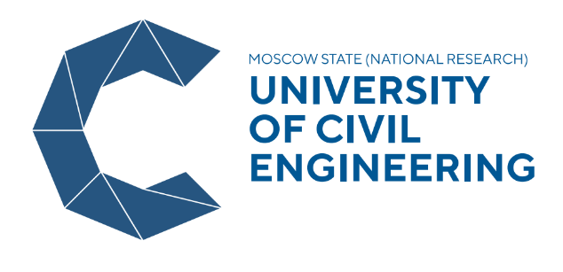

National Research Moscow State University of Civil Engineering

KOLOMNA: URBAN RECONSTRUCTION CHALLENGE IN ANCIENT RUSSIAN TOWN CONTEXT
31 January – 11 February 2022 (two-week course)
Moscow

Application form
Photo

Surname
Given name
Male/female
Date of Birth
Place of Birth
Country of citizenship
Name of University (full)
Degree programme (Bachelors, Masters, PhD)
Field of study
Home address
Phone
E-mail address
Level of Russian language | - Full Beginner  - Elementary level  - Intermediate level
How did you get to know about the Winter School?
At which Russian Consulate /visa center are you going to apply for a visa?
Please attach a copy of your passport for preparation of invitation for visa

